**VISUALIZATION TOOL FOR ELECTRIC VEHICLE CHARGE AND RANGE ANALYSIS**

**1.INTRODUCTION**

**1.1Overview**

The project gives overview on **Visualization Tool for Electric Vehicle charge and Range** **Analysis**. Help of the Datasets we done many Activities that all are Represents with some

Information like Charging Stations by region and type in India, Different EV cars in India, Price for different cars in India Etc…. Above mentioned topics are reflecting as a bar diagram, Pie chart, Bubble chart and Map. From above mentioned visualizations we created Dashboard and Story. At end of the project we done web Integration using Story and Dashboard. This is the overview of this Project.

**1.2Purpose**

With no tailpipe, pure electric cars produce no carbon dioxide emissions when driving. This reduces air pollution considerably. Put simply, **electric cars give us cleaner streets making our towns and cities a better place to be for pedestrians and cyclists**.

**2.PROBLEM DEFINITION & DESIGN THINKING**

**2.1 Empathy map**

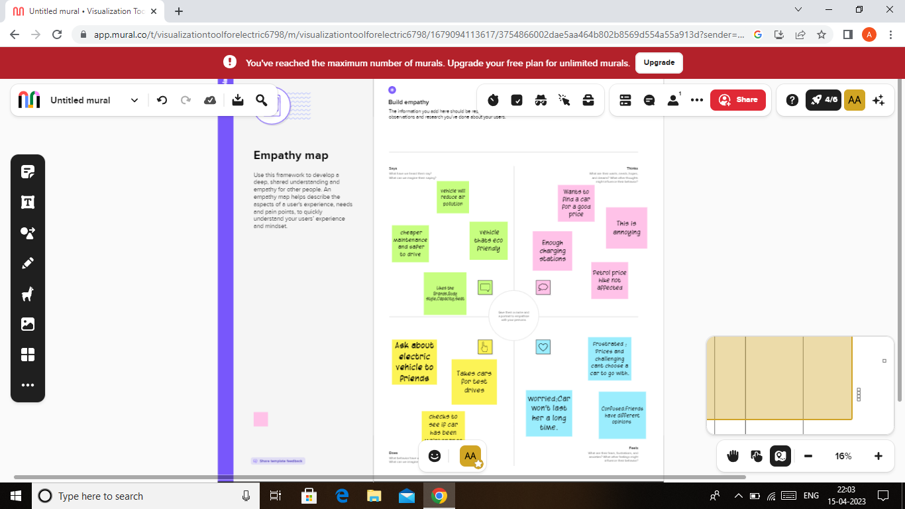

**2.2Ideation & Brainstorming Map**

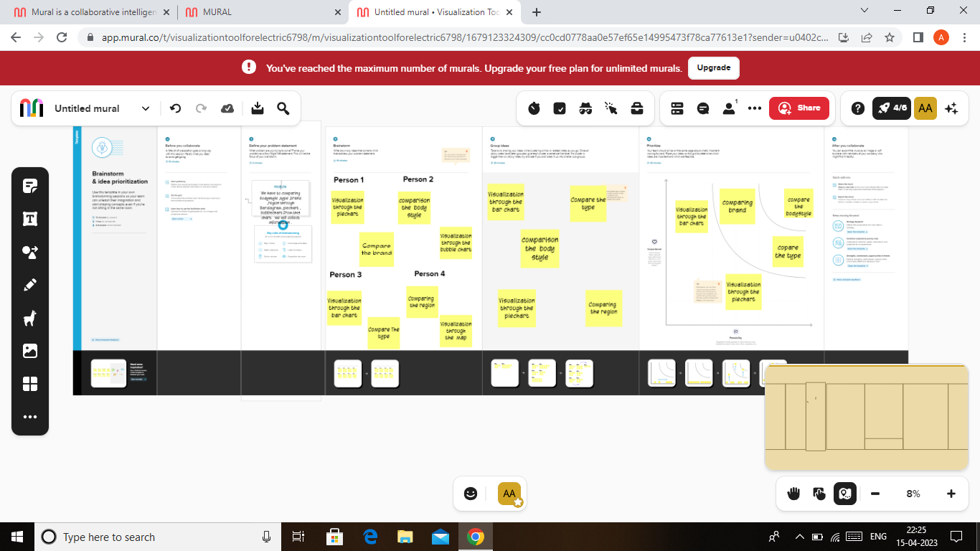

**3.RESUL**T

The following Visualizations we find out using dataset Charging stations by region and type in India, EV charging station map of India, Top speed for different brands, Different EV cars in India, Price for different cars in India, Top ten most Efficient brands, Brands According to body style, no of models by each brand through the bar chart, pie chart, bubble chart also we attached dashboard and story.

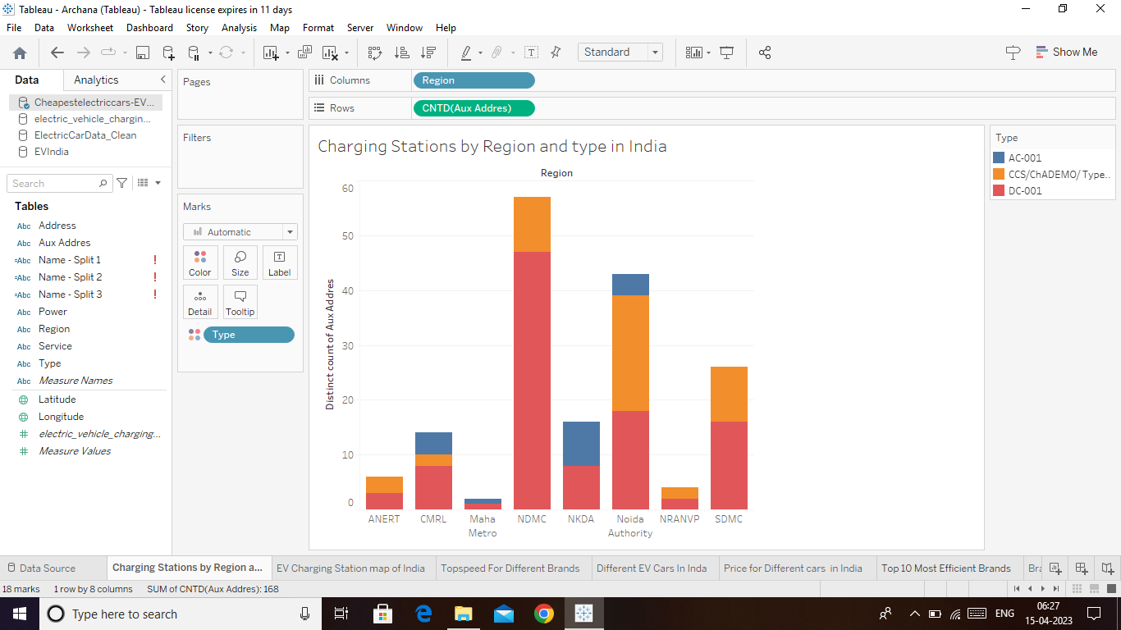

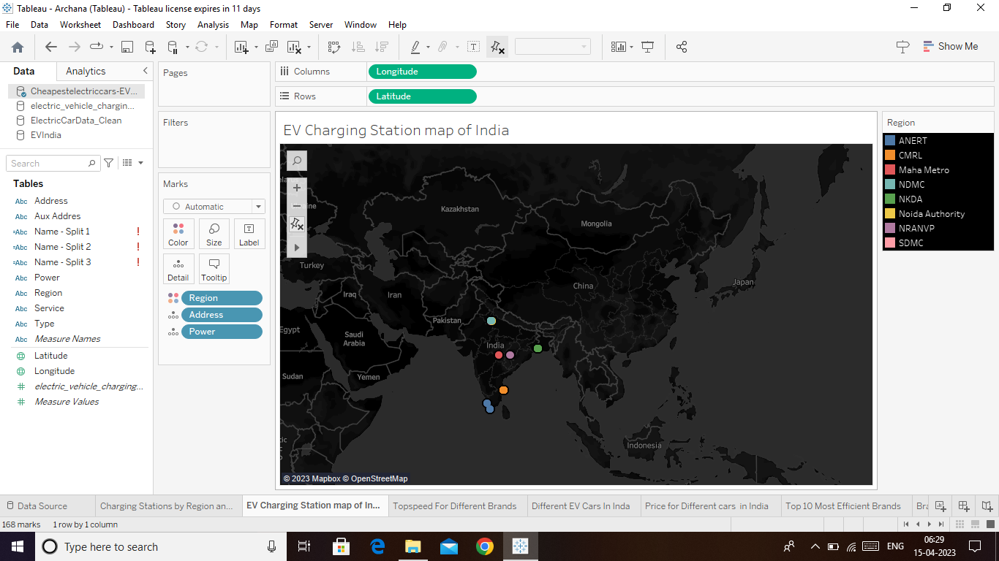

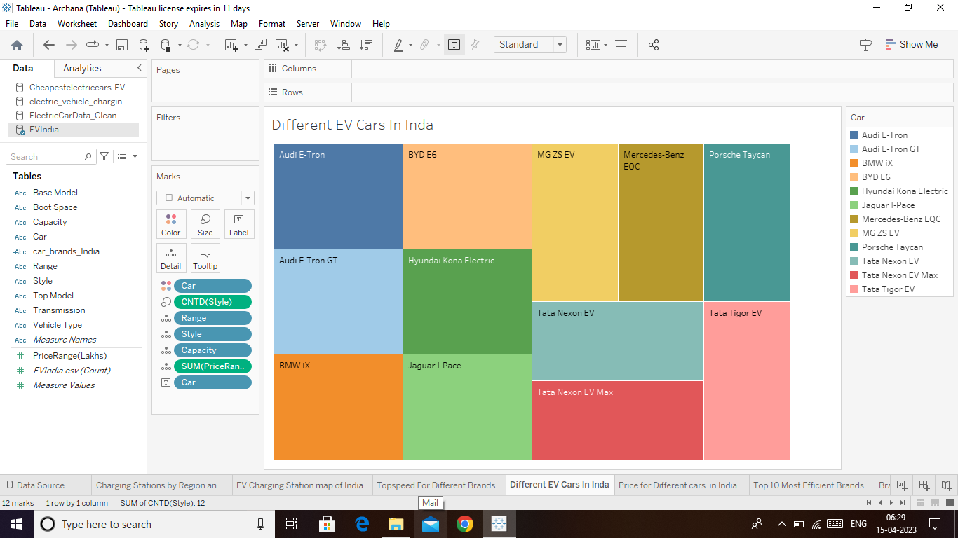

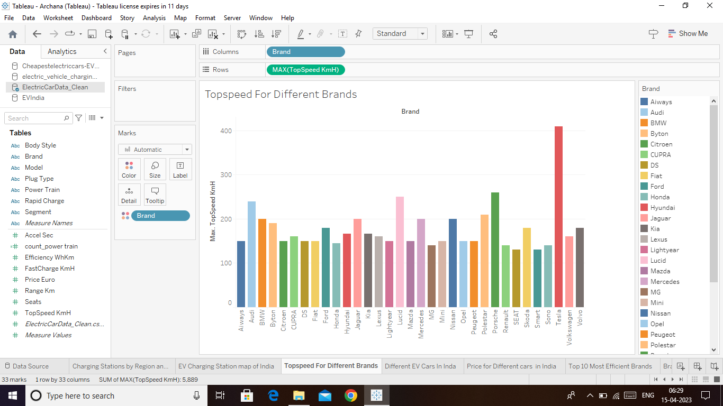

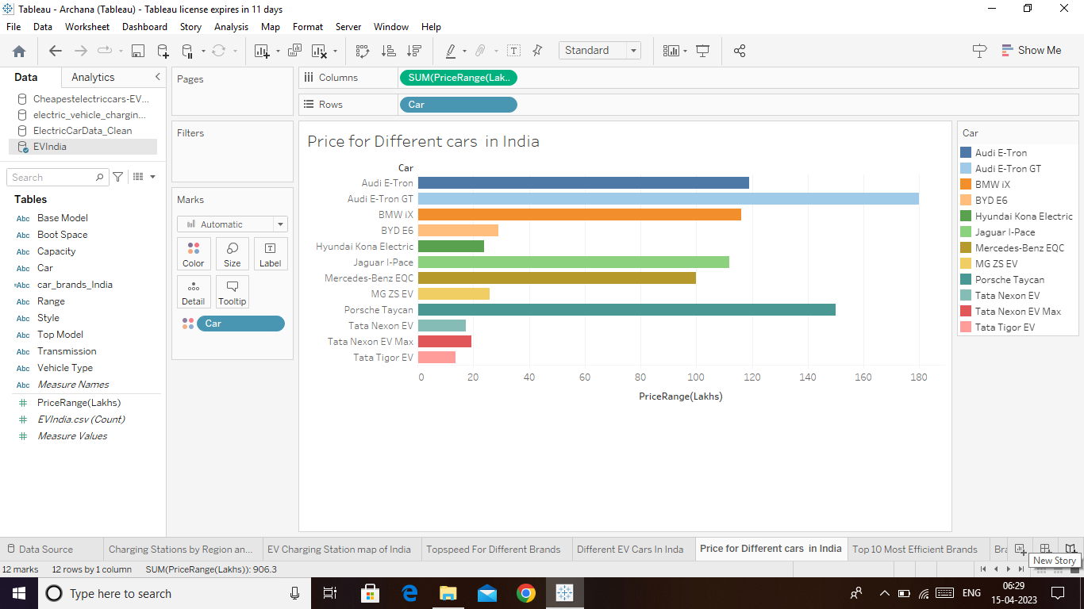

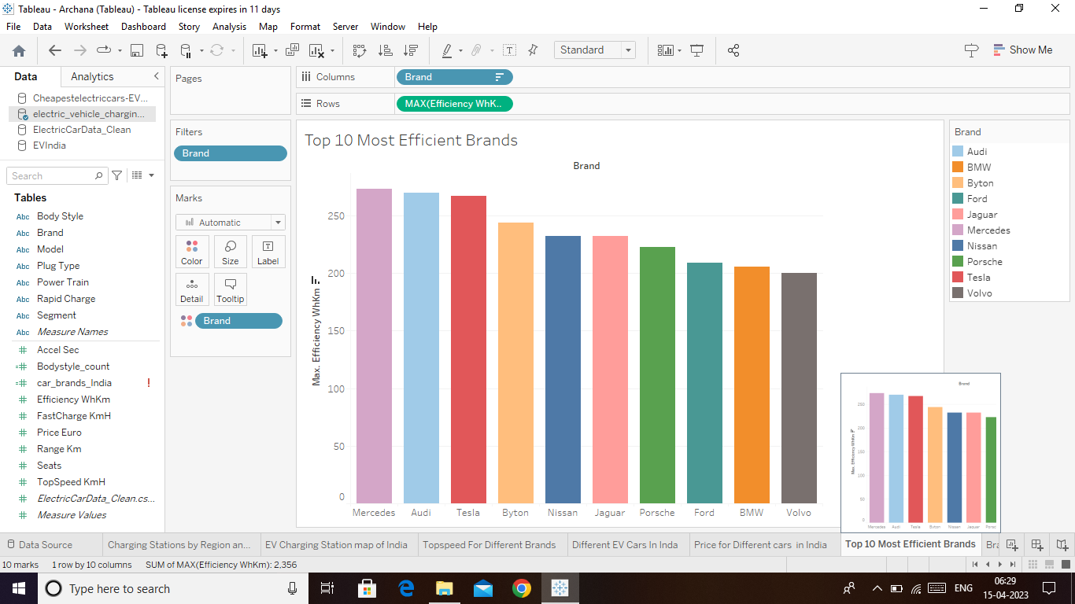

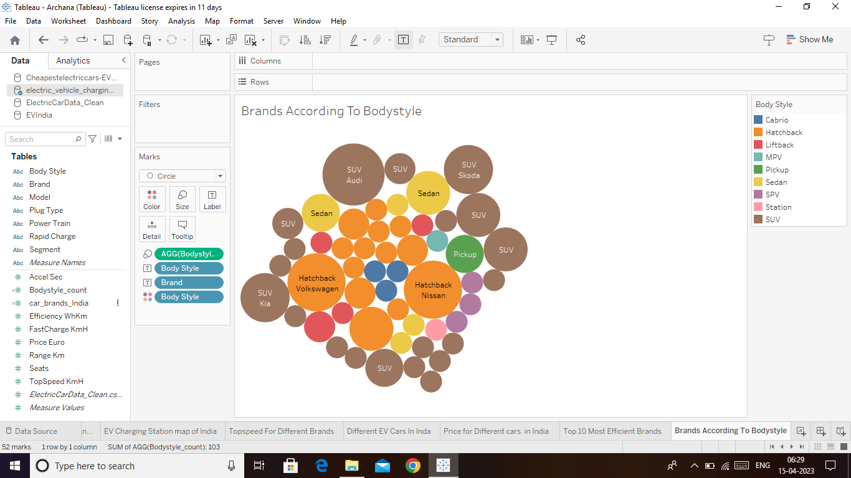

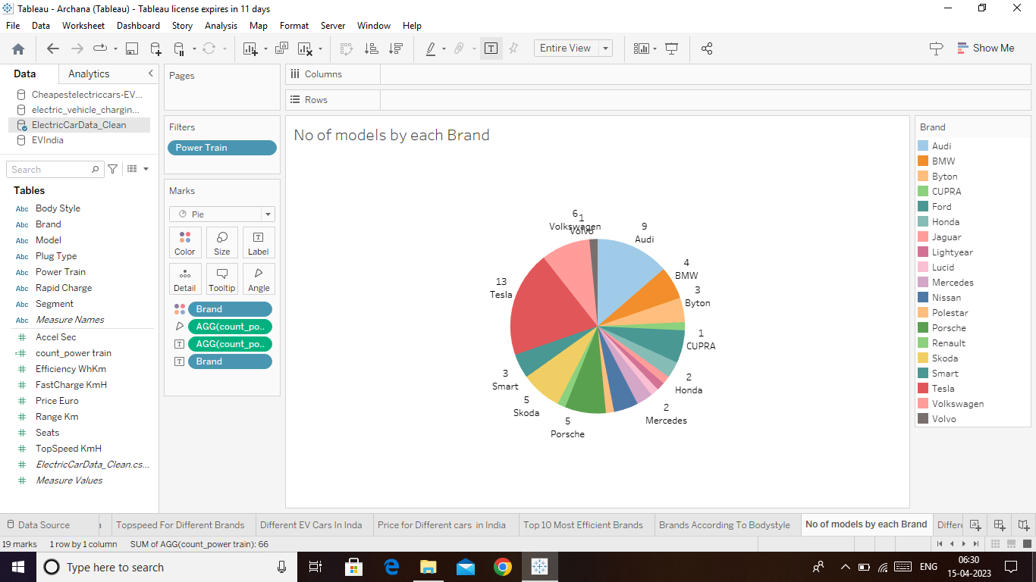

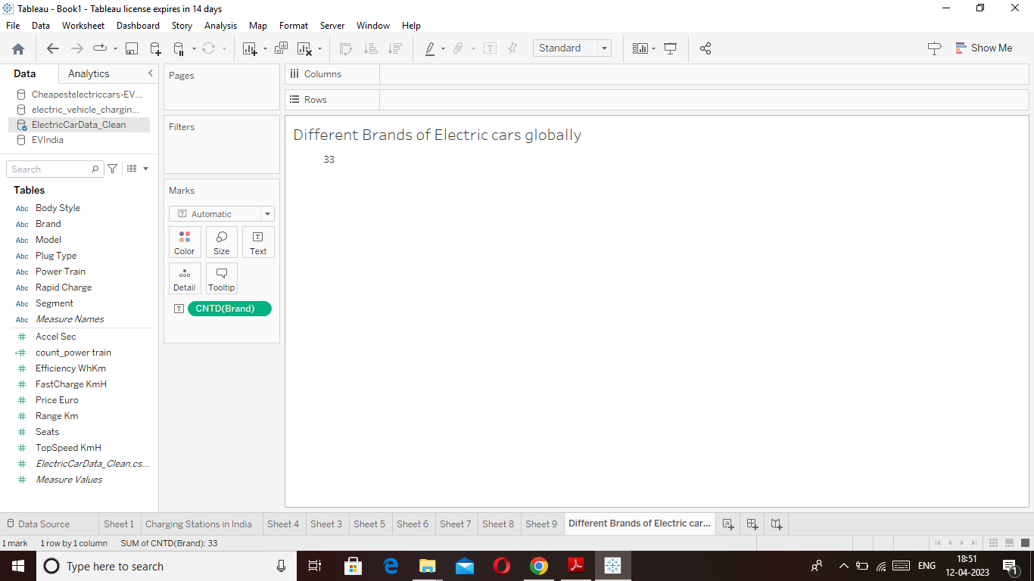

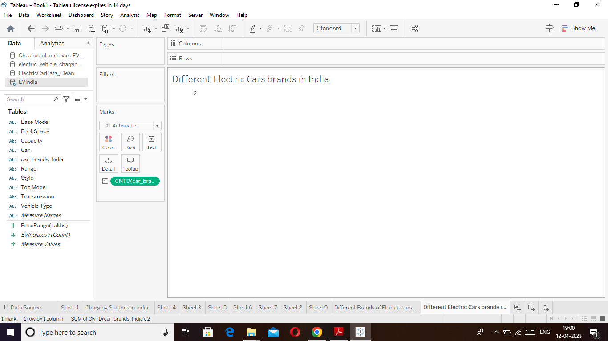

**Dashboard**

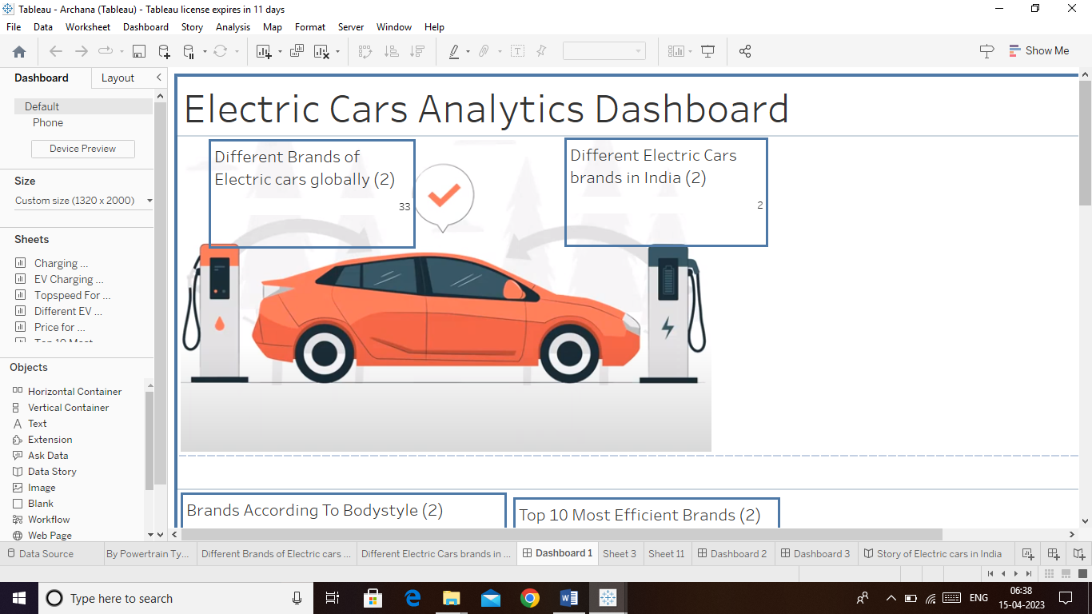

**Story**

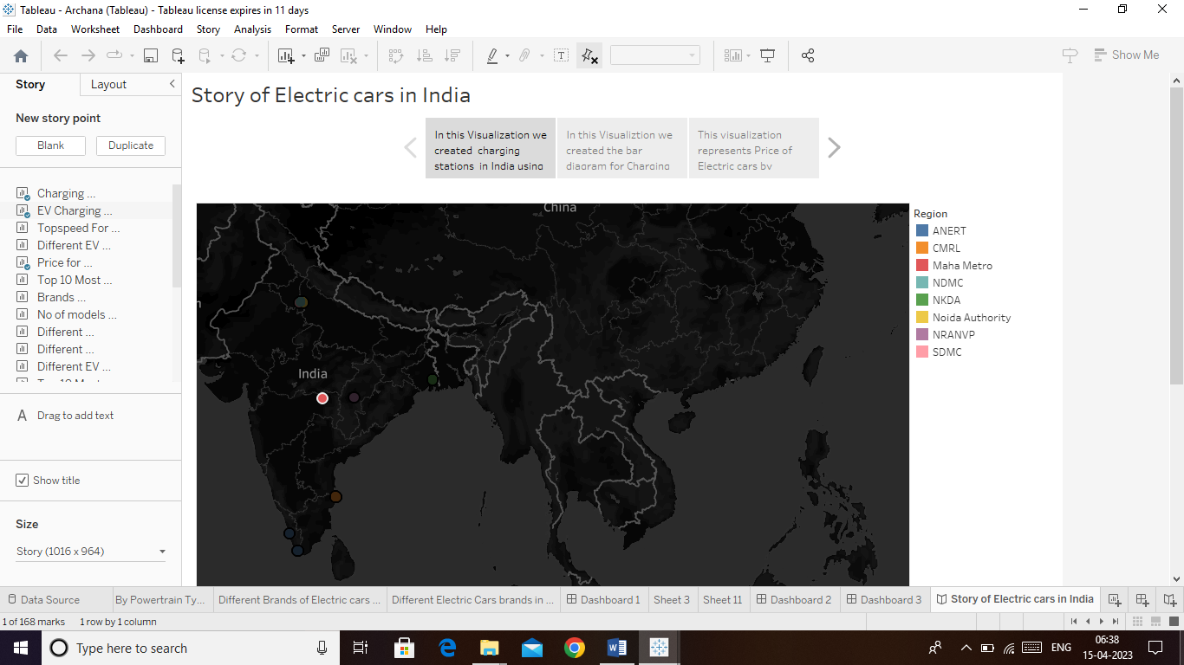

**4.ADVANTAGES & DISADVANTAGES**

**ADVANTAGES**

* No fuel required so you save money on gas.
* Environmental friendly as they do not emit pollutants.
* Lower maintenance due to an efficient electric motor.
* Better Performance.
* Easy to operate.
* No licence and Registration Needed

**DISADVANTAGES**

* Higher Purchase cost.
* Low speed and Range.
* Slow charging.
* Problem for Fuel-Producing Countries
* Fewer User

**5. APPLICATIONS**

Electric vehicles use electricity **to charge their batteries** instead of using fossil fuels like petrol or diesel. Electric vehicles are more efficient, and that combined with the electricity cost means that charging an electric vehicle is cheaper than filling petrol or diesel for your travel requirements.

**6.CONCLUSION**

In this project I learned many things about electric vehicle we created many visualizations every visualization giving many information about electric vehicles charging stations, price for different cars,

Top speed for different brands etc., you can understand with the help of the diagram. After that we created Dashboard and story regarding electric vehicle and also created web integration using Html.

**7.FUTURE SCOPE**

Hereafter people want to know about advantages of electric vehicle we can completely reduce using of petrol, diesel. Definitely we can make green India and also make a noise free environment.

**8.APPENDIX**

file:///C:/Users/ELCOT/Desktop/Electric%20vehicle%20Tableau/index.html